**Project Design Phase-II**

**Technology Stack (Architecture & Stack)**

|  |  |
| --- | --- |
| Team ID | PNT2022TMID22515 |
| Project Name | IoT Based Safety Gadget for Child Safety Monitoring and Notification |

**Technical Architecture:**

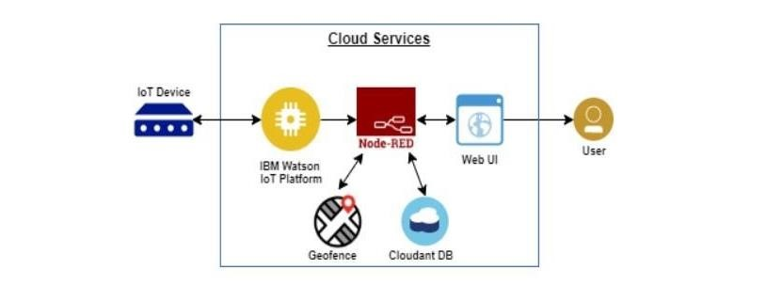

**Table-1 : Components & Technologies:**

|  |  |  |  |
| --- | --- | --- | --- |
| **S.No** | **Component** | **Description** | **Technology** |
| 1. | User Interface | The communication protocol being used in the proposed solution might act as an interface the way like WiFi , Bluetooth and Zigbee. | MIT App |
| 2. | Application Logic-1 | The data to be collected and sent to authenticators’s via GPS to easily locate access and monitor the child. | IBM Watson STT service, Python |
| 3. | Database | Data to be segregated and secured in the form relational DBMS. | MySQL |
| 4. | Cloud Database | IBM | IBM Cloudant |
| 5. | File Storage | File storage requirements | IBM Block Storage or Other Storage Service or Local Filesystem |
| 6. | External API-1 | To access the children location | GPS location monitoring etc. |
| 7. | Infrastructure (Server / Cloud) | Application Deployment on Local System / Cloud Local Server Configuration | Cloud Foundry |

**Table-2: Application Characteristics:**

|  |  |  |  |
| --- | --- | --- | --- |
| **S.No** | **Characteristics** | **Description** | **Technology** |
| 1. | Open-Source Frameworks | The proposed solution being framed in the form an android application providing the end user and easy surveillance of the children(preferably users are parents) | MIT App Inventor |
| 2. | Security Implementations | List all the security / access controls implemented, use of firewalls etc. | Antivirus |
| 3. | Scalable Architecture | The scalability of architecture | Data Storage |
| 4. | Availability | The availability of application | Temperature sensor, pulse sensor, camera, sound recorder |
| 5. | Performance | Design consideration for the performance of the application | GPS tracking |